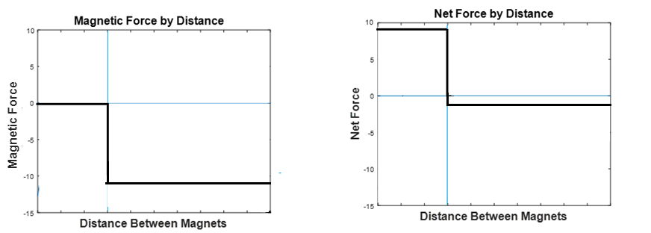

Stable Equilibrium

Unstable Equilibrium